Question 2

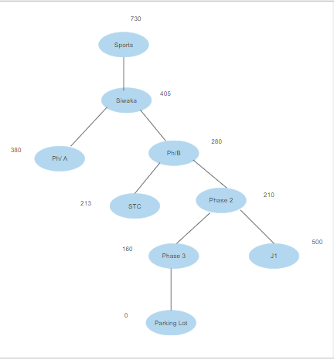

Sports → Siwaka → Ph/B → phase 2 → phase 3 → Parking Lot

450+250 + 112+ 500+ 350 = 1642